Impacts of Covid-19 Pandemic on the Economy of Saudi Arabia
Student’s Name:
Institutional Affiliations:

The Executive Summary
COVID-19 is an infectious disease that formerly was known as '2019 novel coronavirus'. COVID-19 was first detected in China's major cities and provinces. The spread of the infection was also reported in other countries, including Saudi Arabia. The confirmed cases across the globe are alarming, that is over 5.1 million as Saudi Arabia reports over 70,000 cases. The objectives of the research are to determine the impacts of the Covid-19 crisis in Saudi Arabia and assess whether the country will survive the pandemic crisis. The Methodology that will be utilized in this project is descriptive analysis. Descriptive statistics of Saudi Arabia will be utilized in describing the concepts and data included in the research. This pandemic has caused devastative impacts in Saudi Arabia. The pandemic has adversely affected the oil prices to drop due to the decrease in crude demand. With the lowering of the prices, the recession causes a decline in the revenues. Due to the coronavirus, the tourism industry could be hit up to 45percent in 2020. The impact of Covid-19 ranges from 35-45 percent decline in comparison to last year with the reliance on how the country reopens. The hotel industry has been impacted by the low occupancy ratio. Through the research, we shall be able to determine to delineate the possible measure and recommendations in mitigating the adverse impacts that are caused by this pandemic issue. Saudi Arabia is able to survive the Covid-19 pandemic crisis as the countries' expenditure will be cut, and there will be a delay in the Kingdom's vision 2030 economic diversification strategy. Besides, the country has oil reserves; this shows that is the economy begins to open, it will be the first beneficiary in supply its natural oil resources
Introduction
COVID-19 is an infectious disease associated with the same family as Severe Acute Respiratory Syndrome (SARS). Formerly the disease was known as '2019 novel coronavirus'. COVID-19 was first detected in China's major cities and provinces. The spread of the infections was also reported in other countries, including Thailand, Hong Kong, the United States, Macau, South Korea, and Taiwan. The common symptoms of Covid-19 are but not limited to, breath shortness, cough, and fever. The infections result in pneumonia or breathing difficulties in severe cases. The symptoms of the diseases are correlated to the influenza virus; thus, it requires more testing to confirm the patient's status, whether he or she is Covid-19 positive. The confirmed cases across the globe are alarming, that is over 5.1 million as Saudi Arabia reports over 70,000 cases. This pandemic has caused devastative impacts in Saudi Arabia. The pandemic has adversely affected the oil prices to drop due to the decrease in crude demand. With the lowering of the prices, the recession causes a decline in the revenues. Due to the coronavirus, the tourism industry could be hit up to 45percent in 2020. The impact of Covid-19 ranges from 35-45 percent decline compared to last year with the reliance on how the country reopens. A low occupancy ratio has impacted the hotel industry.
Objective of the Research Project
- To determine the impacts of Covid-19 crisis in Saudi Arabia
- To assess whether the country will survive the pandemic crisis
Importance of the research project
This assists in the determination of the strategies that are employed by Saudi Arabia nation and the efficacy of the implemented measures. Through this research, we shall be able to determine the existing knowledge gaps and misconceptions and delineate the possible measures and recommendations in mitigating the adverse impacts of this pandemic issue. The research study will provide descriptive data that will be significant for the associated authority and the planning agencies in implementing or deploying measures that are geared toward mitigating the Covid-19 infections and its impacts upon the economy of Saudi Arabia. Besides, the study creates awareness of adopting healthy lifestyles that are made into managing and preventing complications.
Research Project Methodology and Hypotheses
The Methodology that will be utilized in this project is descriptive analysis. Descriptive statistics of Saudi Arabia will be utilized in describing the concepts and data included in the research. There will also be a simple graphic analysis to form quantitative data analysis.
The hypotheses are that Saudi Arabia is prepared to address the crisis and will survive in this pandemic crisis

Literature Review
Viral Etiology
As the year 2019 ends, identification of novel coronavirus was determined to the causative of a cluster of pneumonia incidences among residents in Wuhan, in China. The scientist in China associated pneumonia to unknown coronavirus strain, which was designated as 2019-nCOV. The initial symptoms were reported on December 10th, and the other 24 cases were also discovered, which were linked to the seafood market. In January 2020, the first death case of Covid -19 was reported as 41 other cases were clinically confirmed. At the end of January, the Covid-19 spread to the major cities as well as the provinces in China. 571 cases and 17 deaths were reported in China. The infection rapidly spread in environs of China, resulting in an epidemic, and this was charted by an increasing number of diseases across the world. Confirmed cases in countries such as Thailand, Hong Kong, the United States, Macau, South Korea, and Taiwan were also reported.
Mode of Transmission
The primary mode of transmission of Covid-19 is individual to individual contact with respiratory droplets emanating from one of the infected individuals. Upon sneezing or coughing, the respiratory secretions infect the other individual when he or she makes direct contact. The transmission of the infection can also occur when an individual touches contaminated surfaces and then touches their face that is mouth, nose, and eyes. The virus is capable of surviving on surfaces for some hours, but the risk can be mitigated through the use of a disinfectant.
Individuals at high risk: People at any given age can acquire Covid-19 on a daily basis. Old aged and individuals having chronic medications, for instance, heart diseases, diabetes, among others, are at higher risk of developing severe signs and symptoms. Limited information is available on the Covid-19 prevalence among the children since few confirmed cases are linked to children. In some cases, the virus is fatal, especially the older adults who have pre-existing medical conditions.
This is portrayed in figure 1 below: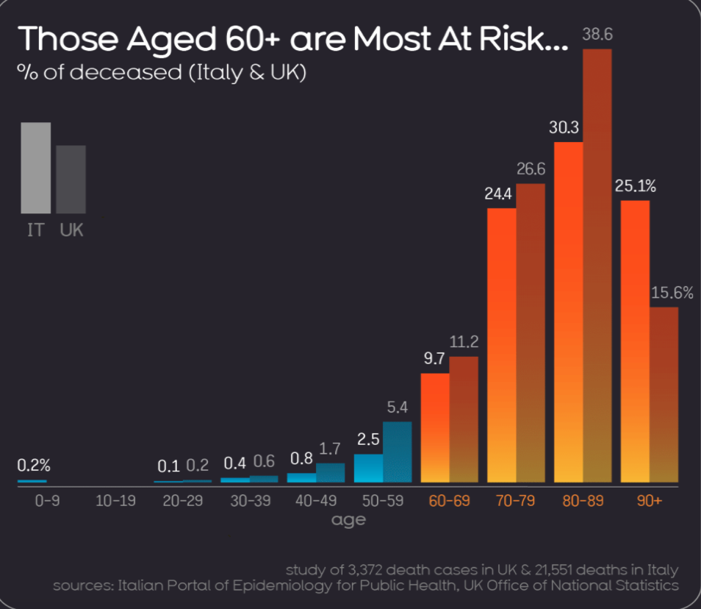Source:https://informationisbeautiful.net/visualizations/covid-19-coronavirus-infographic-datapack/
Clinical Manifestations: Pneumonia is perceived to be the most severe manifestation of the infection, characterized by breath shortness, coughing, and fever. The Covid-19 symptoms can be mirrored as influenza symptoms or the common cold.
Covid-19 Treatment: Currently, there is no available Covid-19 vaccine. Nonetheless, most of the symptoms related to Covid-19 can be treated as a healthcare provider can administer care to the victims making the infection less perilous. Numerous clinical trials have been conducted to assess the potential therapeutics effective for treating Covid-19.
Prevention of Covid-19
Similar to common cold, the public health methods are vital to reducing the spread of the diseases. The public health processes entail daily preventive strategies that includes but not limited to:
- The sick individuals should stay at home and isolate themselves from other members of the family.
- When a person is sneezing or coughing, one is advised to cover their mouth and nose with flexed elbow or tissue usage. The tissues should be disposed of immediately after usage.
- Every person is expected to rinse their hands habitually with running water and detergent.
- The surfaces or objects which are touched regularly should be cleaned.
With the increase of investigative research and exploration of the disease, the public health professional will probably recommend other additional strategies or actions to be followed.
Similarities of Covid-19 and Influenza
The first similarity between Covid-19 and Influenza is that they both have analogous symptoms. Both of the diseases cause respiratory infections, which range from asymptomatic to severe infections and, ultimately, death. Secondly is the mode of transmission of the infections are the same. The virus is passed on through direct contact, respiratory droplets as well as fomites. In addition, similar public health strategies are adopted to prevent infections, such as hand hygiene and excellent respiratory etiquette. That is coughing or sneezing into the elbow or a tissue, and then the tissue should be disposed of immediately.
Differences between Covid-19 and Influenza Virus.
There are significant differences between the two viruses. The primary difference is in the speed of the transmission. The incubation period of Influenza has a diminutive median and has shorter serial intervals that are the amount of time between the successive cases as compared to the Covid-19 virus, which has serial intervals approximated between 5-6 days. The serial interval of Influenza is 3 days, which signifies that Influenza spreads faster as compared to Covid-19.
Besides, the possibly pre-symptomatic influenza transmission is the primary mode of transmission, whereas, in Covid-19, there are some individuals who can shed of 24-48 hours before the onset of the symptoms, though this does not appear to be the primary mode of transmission.
In the transmission of Influenza, the most vital driver is the children. On the other, children are less affected by Covid-19 as compared to adults. The rates of clinical attacks are low for the 0-19 age group. Those who are at risk for Covid-19 are the older adults and those with prevailing conditions, whereas children are the most risk population for influenza infection. Other affected populations include pregnant women, the elderly, and the people with immunosuppressed.
There is a higher mortality rate for Covid-19 as compared to Influenza cases. Even though the rate of mortality for Covid-19 is yet to be fully known, the crude mortality rate is 3-4 percent, whereas, for seasonal Influenza, the rate is below 0.1 percent. It is important to note that the mortality rate is usually determined by the accessibility to quality health services and other significant factors.

(UNICEF NYHQ)Key Messages and Actions for COVID-19 Prevention and Control in Schools March 2020
https://www.who.int/emergencies/diseases/novel-coronavirus-2019/question-and-answers-hub/q-a-detail/q-a-similarities-and-differences-covid-19-and-influenza#:~:text=Mortality%20for%20COVID%2D19,quality%20of%20health%20care
https://www.who.int/emergencies/diseases/novel-coronavirus-2019/question-and-answers-hub/q-a-detail/q-a-similarities-and-differences-covid-19-and-influenza#:~:text=Mortality%20for%20COVID%2D19,quality%20of%20health%20care

